Ada Full Gospel Annual Hayride
Games!
Hotdog, Smores & More!!!
Everyone is invited!!!
October 16, 2021
5-9pm
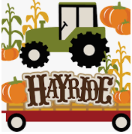

Join our soup cook-off
Must have soup entered by 5pm
1047 State Route 235
Ada, Ohio 45810
419-634-6132

